**Annex 2.3.**

**Antenna**

1. **Passive antenna**
   1. **Antenna characteristics:**

The antenna may be considered to be the most important component of a fixed service system in terms of frequency coordination and in determining spectrum allocations also to other services. Generally, antennas with higher levels of discrimination to off-axis signals facilitate possibilities for frequency re-use. It is essential that detailed radiation pattern envelope data for antenna products are taken into account for assignments. Parameters should include antenna’s physical diameter and on-axis gain as well as the antenna 360° radiation pattern envelope for co-polar and cross-polar orientation, in order to facilitate their use in detailed frequency coordination and sharing studies. Most FS links have parabolic antennas, including front feed antenna, offset feed antennas, Cassegrain antennas, and Gregorian antenna.

* 1. **Antenna Parameters:**
* Radiation Patterns: Radiation patterns are usually provided by the antenna manufacturer for a specific antenna. These are graphical plots, one for horizontal plane (or azimuthal) and one for the vertical plane (elevation).
* Polarization: Polarization of the radiation from an antenna is given by the fact, that the current flow direction in an antenna is a vector quantity, to which spatial orientation of the electric and magnetic fields are related. Single linear antennas in free space produce linear polarized waves in the far field, with the electric vector in a plane parallel to the radiating element and passing through its axis. .
* Impedance: The impedance of an antenna depends on the radiation resitance, the reactive storage field, antenna conductor losses, and coupled impedance effects from nearby conductors.
  1. **Gain:**

The gain of a parabolic antenna G is expressed as follows:

$Gmax=\frac{4πA}{λ^{2}}e_{A}=\frac{π^{2}d^{2}}{λ^{2}}e_{A}$ (1)

where:

* A is the area of the antenna aperture,
* d is the diameter of the parabolic reflector,
* λ is the wavelength of the radio waves, and
* eA is the aperture efficiency.

Figure 1 shows the antenna gain calculated by using the Equation (1). The diameter of the parabolic antenna for FS can be selected by considering the link distance, carrier frequency, output power, and availability of the link.

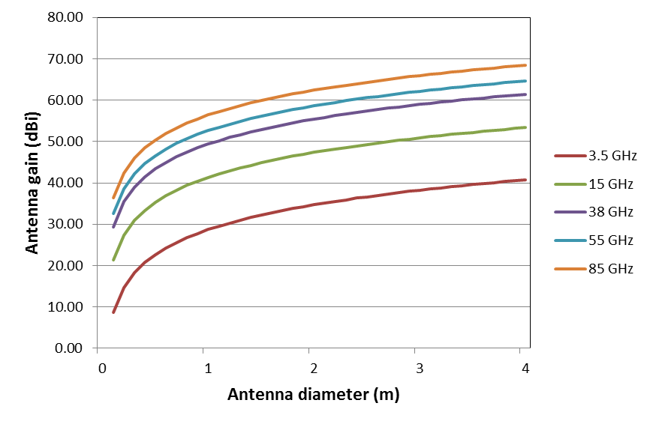

Figure 1.

1.3.1.For frequencies in the range 1 GHz to about 70 GHz, in cases where the ratio between the antenna diameter and the wavelength is greater than 100, the following equations should be used:

 for         0*m*

 for       *m*     

 for 100    *s*

 for         *s*    °

where:

*G*(φ) : gain relative to an isotropic antenna

φ: off-axis angle (degrees)



*G*1 : gain of the first side-lobe = 2 + 15 log 





**.2 f**or frequencies in the range 1 GHz to about 70 GHz, in cases where the ratio between the antenna diameter and the wavelength is less than or equal to 100 the following equations should be used (see Notes 6 and 7):

 for   0º  <  φ < φ*m*

 for     φ*m*  < φ < 100 

 for 100   < φ < 48º

 for    48º < φ < 180º

**3** or frequencies in the range 100 MHz to less than 1 GHz, in cases where the ratio between the antenna diameter and the wavelength is greater than 0.63 (*Gmax* is greater than 3.7 dBi), the following equations should be used:

 for         0º < φ < φ*m*

 for       φ*m*  < φ < 100 

 for 100    < φ < φ*s*

 for         φ < φ < 180°

where:



calculate the beamwidth an aperture antenna the following equations should be used:

Δφ = k x λ/D ~ 70 x λ/D

where

* λ – wavelength,
* D – the diameter of the parabolic antenna
* k – beamwidth constant (~ 70 in many cases)

1. **Active antenna**
   1. **Antenna with steering beam**

Near future evolution antenna technology will be in close relationship to the deployment of new mobile access networks, LTE and 5G, which will focus on small sized cells especially in urban areas., The backhauling will require denser and shorter link networks. Equipment may be installed on light poles at street level to avoid visual impact. This will increase the use of smaller antennas integrated in the equipment. Such developments may be a useful help for link activation and for compensation of slight modifications due to poles vibrations and bending caused by various unpredictable reasons. In addition also the negative effect of multipath reflections from buildings nearby.

The consequent loss of directivity might be compensated using steering antenna, which can keep pointing in adaptive way even in an urban and changing environment where pole can be bent causing pointing misalignment (Figure 2).

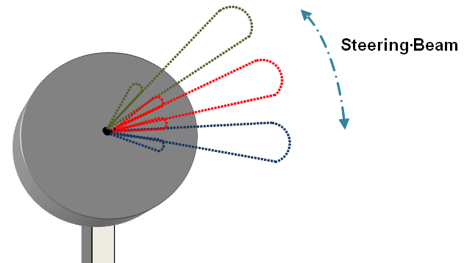

Figure 2.: Antenna with steering beam

* 1. **Beamforming antenna**

Active antennas may also be driven by “beam-forming” algorithms for minimizing interference, i.e. minimizing the gain in such a direction, where interference is detected. This will be important in dense urban environment for street level BS backhauling, where reflection/diffraction effects are dominating . (Figure 3.)



Figure 3.: Beamforming Antenna

1. **Gigabit millimetre-wave links with antenna arrays**

This section provides an example of the performance of gigabit millimetre-wave links. Millimetre‑wave links are used for short-haul and high-capacity transmission due to tranmission charactersitics of  high frequency bands (60--100 GHz) and wide channel bandwidths . Their large bandwidth enables to develop high-capacity transmission systems for mobile backhaul or local access networks that can transmit STM-4 (622 Mbit/s), or Gigabit Ethernet (more than 1 000 Mbit/s).

The typical technical characteristics of fixed systems are shown in Recommendation ITU-R F.758. For such systems, adaptive modulation and adaptive bandwidth technologies are employed. According to the channel quality both modulation level and bandwidth size change automatically..

Since 2012 progress in high-speed devices has enabled the use of bands above 100 GHz for FS applications. Report ITU-R F.2107 describes a feasibility study of a wireless link in a 120 GHz band with ASK modulation scheme for transmission of 10-Gbit/s data along a distance of 5.8 km. In a 120-GHz-band wireless link equipment using QPSK modulation scheme for 10-Gbit/s data transmissions will come up with a considerable shorter maximum link distance.

Since 2010 studies for wireless transmissions using millimetre-wave bands and transmission rates beyond10 Gbit/s have been underway. Figure 3 shows the data rates of experimental millimetre-wave wireless links reported in various technical papers. Most of these reports describe feasibility studies of indoor millimetre-wave wireless links various types of such wireless links..

These improvements in the millimetre-wave wireless link were achieved by the introduction of high-order modulation schemes and/or the increase of bandwidth available in higher frequency bands. These technologies are expected to be introduced into FWS in the near future. For point-to-point links in the 57-64 GHz range high gain directional antenna arrays support multiple gigabit operation.

3.1 Propagation characteristics

Free-space loss is proportional to the square of the operating frequency; therefore, the free-space loss in the 60/70/80/95/120 GHz bands is much higher than the losses in the 2.4 GHz or 5 GHz bands available in many administrations for WLAN operations.

The free-space loss *PLFS* (dB) at a reference distance *d*0 (m) is given by:



where λ  is the wavelength (m). The average path loss over a distance *d* (m) can be determined using the following path loss exponent model based on Recommendation ITU-R P.675 (ex-CCIR):



where:

 the average path loss (dB) at a particular distance *d*

*n*: the path loss exponentthat characterizes how fast the path loss increases with transmit and receive antenna separation. Fig. 1 shows the simulated results of the received signal level (dBm) as a function of the distance from the transmit antenna. The simulated results are provided for the 2.4/5.5/60/70/80/95/120 GHz bands. In this simulation, it is assumed the transmit power *Pt* is 10 dBm, the transmit and receive antenna gains (*Gt* and *Gr*) are unity, *n* is 2.1, and the oxygen absorption is 15 dB/km for the 60 GHz band and zero otherwise.

Description: Description: Description: Description: Description: 大気減衰_3

Figure 4: Received power (dBm) vs. distance (km)

The path loss at 60 GHz is much higher than the losses at other frequency bands because of the oxygen absorption, which is detrimental to signal propagation (see Figure 4.)

For the 70/80/95/120 GHz bands, the gaseous absorption is negligible. Fig. 5 shows the attenuation (dB/km) vs the frequency (GHz) due to the gasses and hydrometeors for radio transmission through the atmosphere. The figure indicates that rain has the greatest impact on transmitted signals in the 60/70/80/95/120 GHz bands.

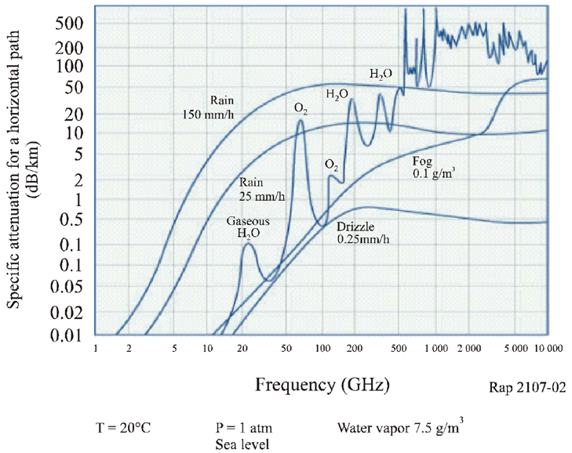

Figure 5. Attenuation due to gasses and hydrometeors

# 3.2 System design considerations for the 60/70/80/95/120 GHz bands

In addition to the propagation medium, the performance of a wireless communication system also strongly depends on the hardware specifications of the transmitter, the receiver, and the antenna subsystems. Design parameters such as amplifier linearity, output power, noise figure, mixer conversion loss, oscillator phase noise, antenna gain, and antenna beamwidth influence the entire system performance. In the millimetre-wave (mm-wave) bands, choosing the parameters mentioned above is a challenging task because of their inter-dependencies. Trade-offs and compromises must be made to ensure a realistic design. Furthermore, the cost of the RF subsystems depends on the volumes of production. As the volume increases, the cost per subsystem decreases. Therefore, for the 60/70/80/95/120 GHz systems to be competitive with systems operating at lower frequencies, the volume of the deployed systems needs to be very high.

**3.3 Advantages and disadvantage of the 60/70/80/95/120 GHz bands**

The advantages of using the 60/70/80/95/120 GHz bands include:

– frequency reuse in dense areas with reduced potential for undesired interference;

– use of smaller size antennas (antenna gains are proportional to the antenna

dimension and the wavelength);

* small size radio equipment as to provide nomadic applications;
* narrow antenna beamwidths (antenna beamwidth is inversely proportional to the operating frequency) which reduce interference and increase frequency reuse;
* potential frequency sharing feasibility with other radio services;

– support for high capacity transmission due to their wider usable bandwidth

The following example demonstrates the increase in system capacity [Haroun *et al.*, 2004] due to the wide bandwidth for 60 GHz and 2.4 GHz systems (*C* = bandwidth × log2(1 + *SNRlinear*)):

– for 60 GHz system with bandwidth of 4 GHz and *SNR* = 18 dB, the capacity, *C* is:

*C* = 4 × 109 × log2 (1 + 63.1) = 24 Gbit/s

– for 2.4 GHz system with bandwidth of 5 MHz, *SNR* = 18 dB, the capacity, *C* is:

*C* = 5 × 106 × log2 (1 + 63.1) = 30 Mbit/s

From the above example, the 60/70/80/95/120 GHz bands are ideal choices for high-data-rate short‑haul links, but further studies are needed to investigate all the system design challenges.

The disadvantages of these bands include:

– signal obstruction by an object or persons;

– oxygen absorption in the 60 GHz range;

– susceptibility to outage in heavy rain and snow-fall regions;

– unsuitable for long-haul transmission.

**References:**

* Radio Regulations (Edition 2012)
* ITU-R Recommendations (F, P)
* ITU-R Reports (F)